TRƯỜNG ĐẠI HỌC CÔNG NGHIỆP  THÀNH PHỐ HỒ CHÍ MINH  KHOA NGOẠI NGỮ | ĐỀ THI GIỮA KỲ  Môn thi : Anh Văn 4  Lớp/Lớp học phần:  Ngày thi: / 07/ 2024  Thời gian làm bài: 45 phút  (Không kể thời gian phát đề)
Họ và tên thí sinh ………………….…………………; MSSV: …………….......…
PART 1: 2.5 points
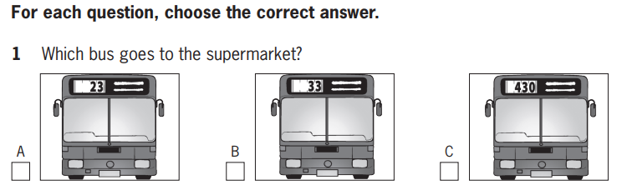
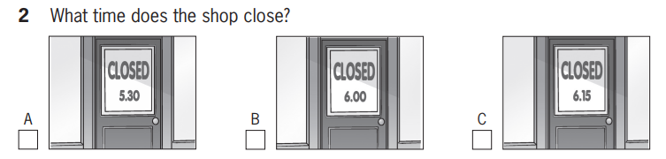
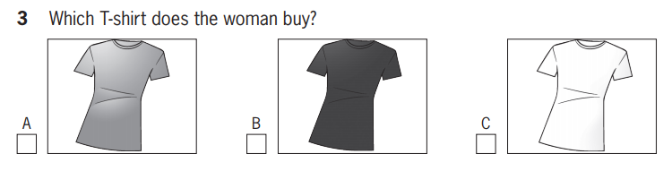
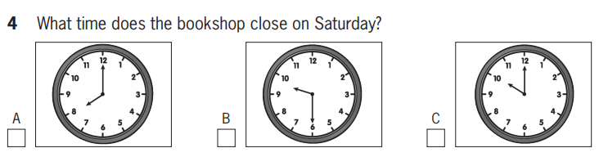


PART 2: 2.5 points
For each question, choose the correct answer.
1. You will hear two friends talking about going skiing.
The girl thinks that going skiing is ___________.
- less fun than a beach holiday
- too dangerous for her and her family
- only exciting for the first few days
2. You will hear two friends talking about professional football.
They agree that _____________.
- footballers are paid too much
- the managers have a difficult job
- there should be less shown on TV
3. You will hear two friends talking about a cycling club.
The boy is _______________.
- suggesting that the girl goes on a ride with him
- persuading the girl to join the club
- describing where the members usually cycle to
4. You will hear two friends talking about a sailing course they did.
They enjoyed the course because _______________.
- the equipment was high quality
- the instructor gave clear instructions
- the conditions were perfect for sailing
5. You will hear two friends talking about a video game.
They think that it would be better if ____________________.
- there were more levels
- the characters were more interesting
- it had better music
PART 3: 2.5 points
For each question, choose the correct answer.
You will hear Zoe talking to her friend, Pete, about a birthday party she is planning.
1. Why doesn't Zoe know how many guests will come to her party?
- She hasn't sent the invitations yet.
- She hasn't decided who she wants to invite.
- No one has received an invitation yet.
2. Guests will probably eat ______________.
- simple food
- their own food
- pizza and chips
3. Who has Zoe invited?
- all her classmates
- a small number of friends
- some people she doesn't know well
4. If the weather's good, Zoe _______________.
- will have a barbecue in the garden
- will have her party in the garden
- will offer her friends some food outside
5. What will some of Zoe's friends do?
- They will bring music CDs.
- They will play musical instruments.
- They will buy her a CD player.
PART 4: 2.5 points

You will hear a radio interview with a young sports star, called Michael.
1. When Michael got his first bike _______________.
- he fell off it all the time
- he rode it whenever he could
- he went for rides with his big brother
2. What does Michael say about his cycling career?
- It's always been easy for him.
- He almost gave up.
- He couldn't have done it without his parents.
3. What is the most difficult thing for Michael?
- not seeing his friends very often
- getting up early in the morning
- going to the gym every day
4. What does Michael say a professional athlete must do?
- eat healthy food
- sleep a lot
- go to the gym every day
5. What does Michael sometimes do to relax?
- read a book
- play sports
- watch films
------------------------- Hết ------------------------------
Lưu ý:
- Đề thi không được sử dụng tài liệu.
- Cán bộ coi thi không giải thích gì thêm.

Tổ Trưởng Bộ Môn Duyệt GV tổng hợp đề thi

ThS. Hoàng Thị Phong Linh ThS. Lê Thị Thuý

